Coach Traub’s Showcase Camp Evaluation
August 5, 2012

Name: ___«Fname» «Lname» ___ Class:___«Year» ___
Ratings are done on a scale of 1 to 10, with 8.0 being an average varsity high school starter.
5 = Likely to get cut from varsity, 10 = Major DI scholarship/professional draft type of player

Stance
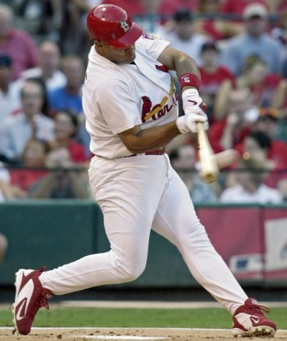
-Flex in the knees
-Athletic Position
-Good Rhythm

Load to Launch Position
-Hands go back to go forward
-Barrel of bat loaded directly above head,
but not wrapped past or behind helmet.
-Weight Back (65-85% over back foot)
-Head Level
-Shoulders Level
-Two Eyes on the Ball

Check Position
-Short to the ball
-Shoulders level

Contact
- Long through the hitting zone (extension)
-Eyes track the ball to the bat
-Pitch recognition (pitch and location)
-Palm Up/Palm Down Position
-Bat Whip
-Shoelaces to pitcher (or ball if OPPO)
-Balance
-Hit against a firm front side

Follow Through
-Extension with the arms
-Balance

_«Overall_Swing»_Entire Swing
(Comprehensive Grade)

____«Balance»_ Balance – Weight on balls of feet (note: graded in BP, typically worse in games)
____«Hand_Path»__ Hand Path – Short to it, Long through it
____«Hit_for_Avg»_ Hit for average (produces line drives w/ backspin, hitting ball where pitched)
Overall Grade
«Overall_Score»
____«Hit_for_Power»__ Hit for power (speed and strength in swing)

Running Times – 60 Yard Dash __ «M_60_Time», «M_60_Time1»_ Throwing Velocity from the field __«Throwing_Velocity»__
Arm Accuracy ___«Throwing_Accuracy»____Hands/Athleticism ___«Hands_Athleticism»____ Fielding Footwork ___«Fielding_Footwork»__
Hitting Comments: «Comments1»
Pitching Velocities: FB __«Fastball_Velo»___ FB Mvmt __«FB_Mvmt»____ FB Command __«FB_Command»_____ Breaking Ball ___«Breaking_Ball_Velo»____
Change __«Change_Velo»_____ Other __«Other_Velo»____ Pitching Mechanics __«Pitching_Mechanics»____
Pitching Comments: «Comments2»
AB1: «M_1st_AB» AB2: «M_2nd_AB» AB3: «M_3rd_AB» Home to First Base Speed: ___«H1B»___
Catcher Pop to Pop times: __«C_Pop_Times»___ Other Comments: «COMMENTS» «Comments21»

Coaches: Aaron Weintraub Cameron Dodd (WTC) Abe Arguello (TX A&M-Kingsville)
Email Addresses: aaron@CoachTraub.com cdodd@wtc.edu houstonvenezuela@yahoo.com
Kevin Brooks (Angelo State): kevin.brooks@angelo.edu Scott Malone: corpusbaseball@hotmail.com

